25/01/2024
Please accept this letter as confirmation that:
All innov8 staff have up to date enhanced DBS/barred list checks which are held on a central system.
All innov8 staff are up to date with their child/safeguarding training, including; Child protection; KCSiE; Safeguarding young people; dealing with disclosures and Prevent Duty. This training is certified by TES.
I can confirm that we also have several First Aiders on site.

Kind regards
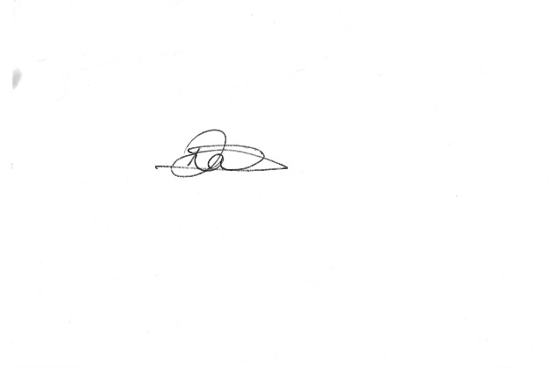

Daniela Symons
Operations Director

